Chapter 14, Problem 46.

For the network illustrated in Fig. 14.85, find

(a) the transfer function H(ω) = V_{o}(ω)/I(ω),
(b) the magnitude of H at ω₀ = 1 rad/s.

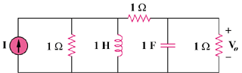

Figure 14.85
For Prob. 14.46.

